We will divide the mock-ups in types of users:

Unregistered user:

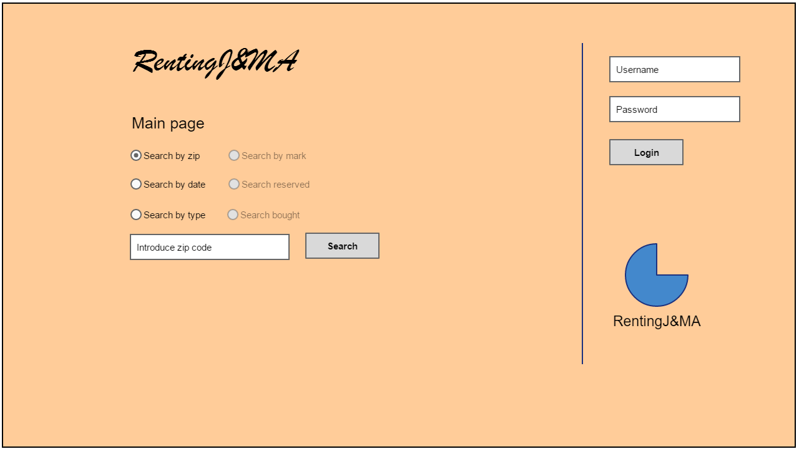

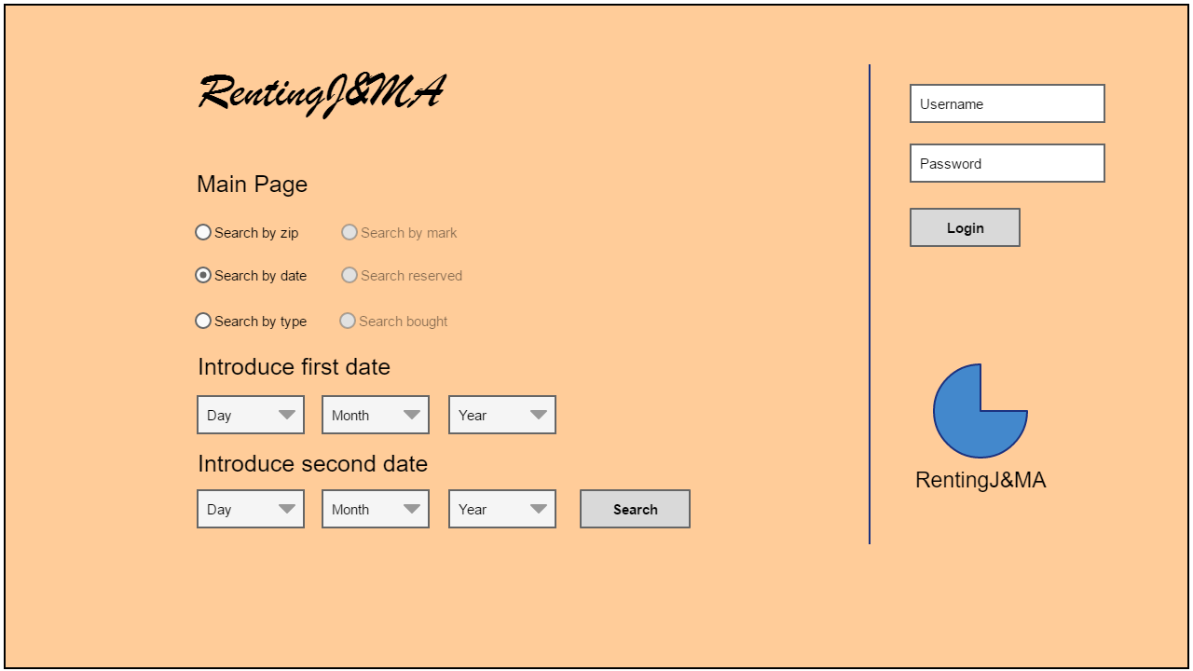

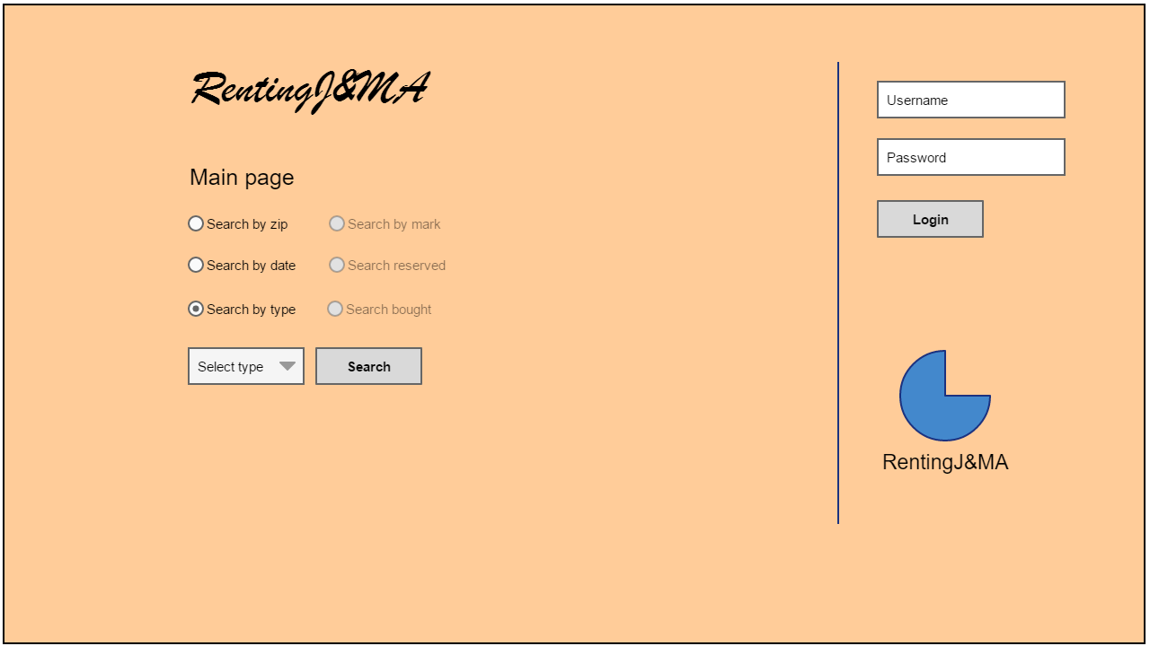

These first three mock-ups are the three kinds of searches that a non-registered user can do. He will need to select the type of search, then introduce the asked information and finally press “Search”.

This is the screen that will appear once he presses “Search”: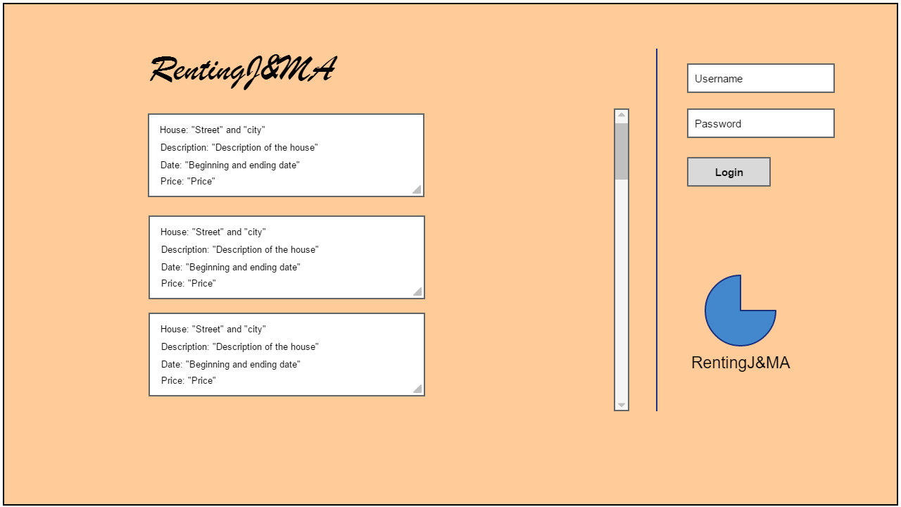

This screen shows the offers and the information that a non-registered user can see.

As we can see, at the top right corner we have the possibility to login and become a registered user by pressing “Login”.

Registered user:

* Guest

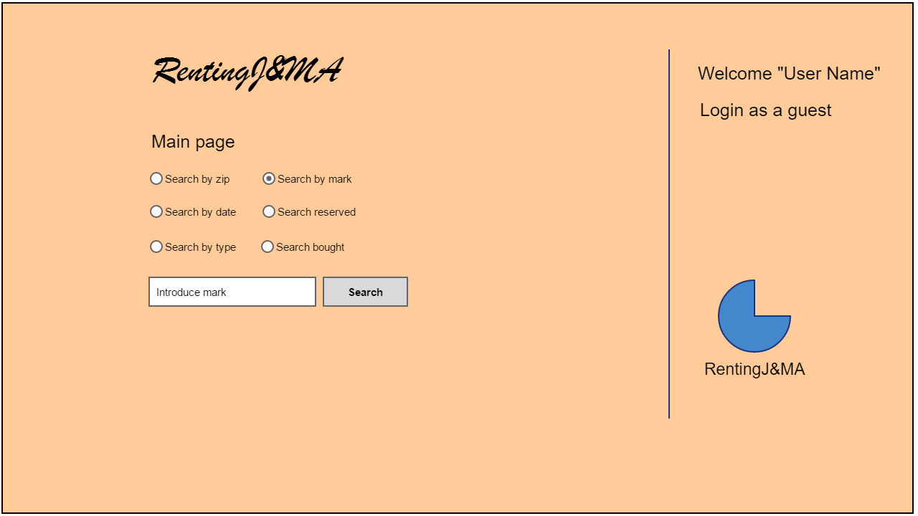

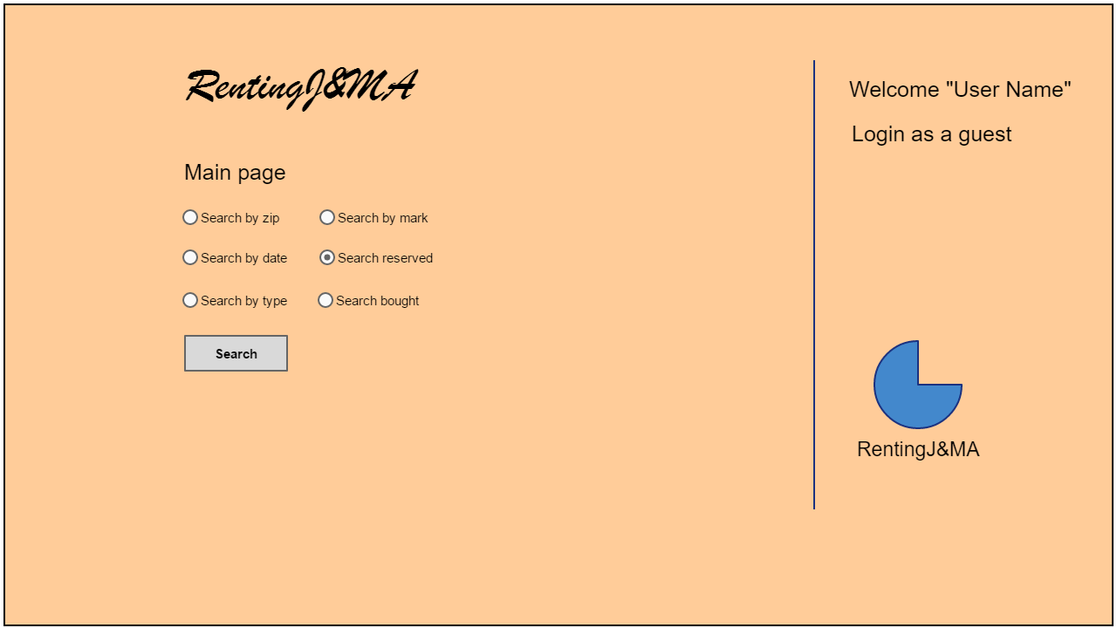

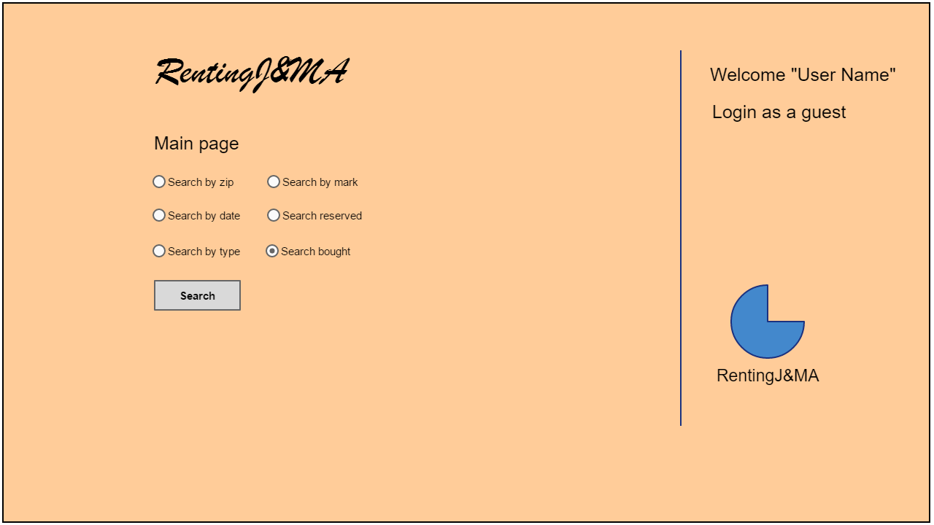

These are the three new type of searches that a registered user can do. We put them in the guest place because at the top right corner we have written “login as a guest”. A host will be able to make these searches too, but changing that to “login as a host”. And both users will be able to access to the first three types of searches too.

Once the guest presses the search button he will see this screen:

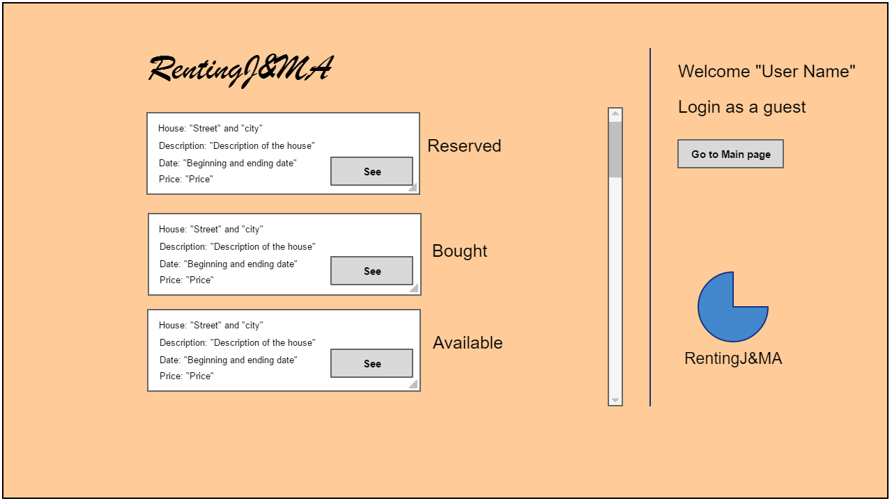

As we can see, we have a list of all the offers searched. Since we are a guest, we can see if the offer is reserved, bought or available.

If we press the “See” button we will go to that specific offer and this is what we will see:

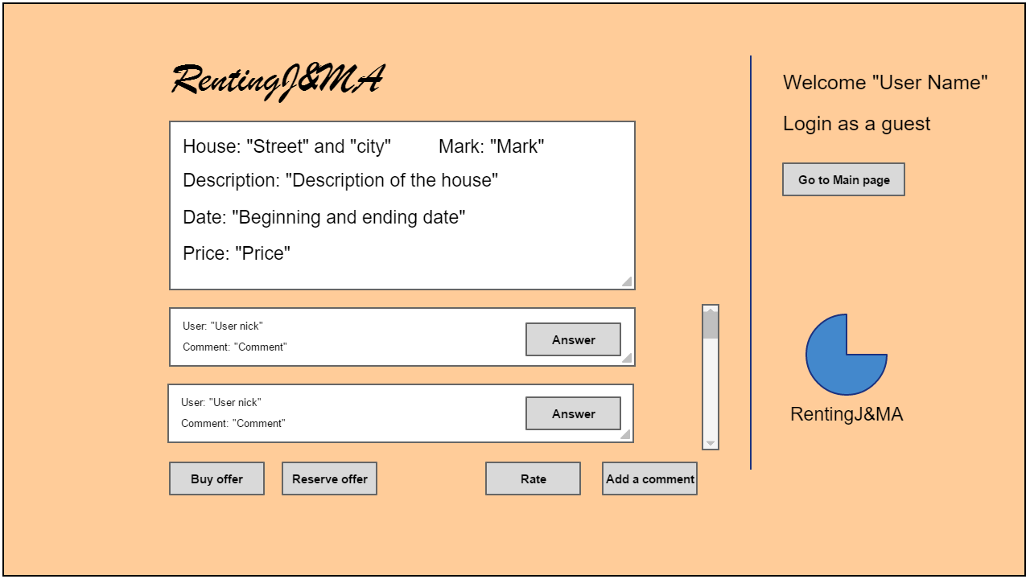

We can see the information a little bit bigger, and we can see the comments.

From this screen we can buy or reserve the offer, but we can also rate the offer or add a comment.

This is also the first time we see the “Go to Main page” button at the top right corner, it will take us to the main page of the user that is logged in, which will be different for every type of user.

* Host

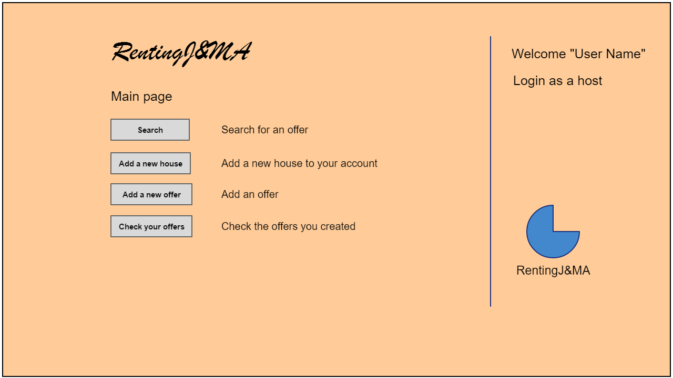

This is the main page of the host. If we select the “Search” button we will go to the same page we saw before, with the six types of searches.

If we select the “Add a new house” button this is what we´ll se:

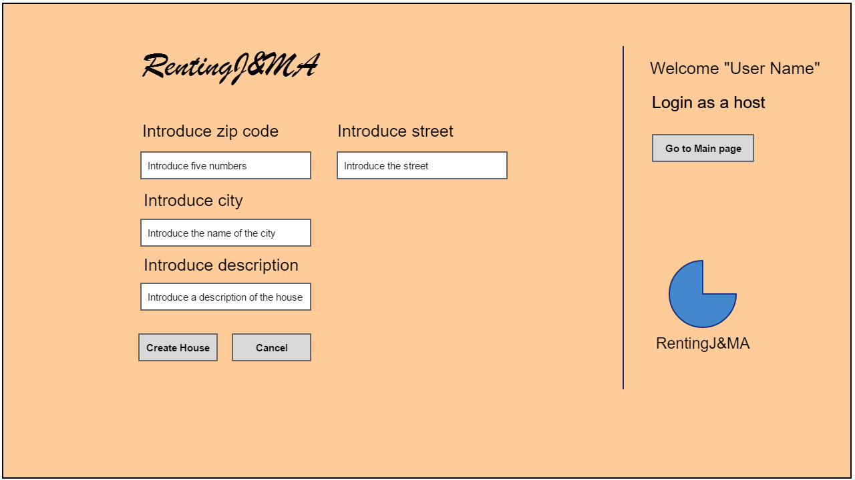

Once we introduce all the information we can press “Create House” and save it into the system.

If we press “Cancel” or “Go to Main page” we will go back to the main page.

This is what we’ll se if we select “Add a new offer” from the main page:

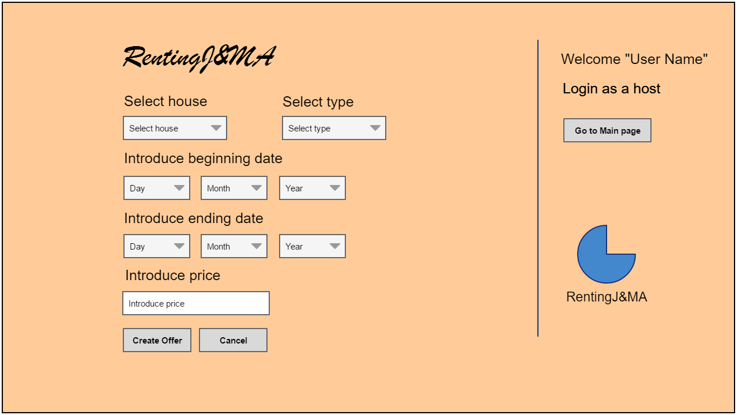

As with the houses, once we have introduced all the information we can select “Create Offer” and save it into the system or “Cancel” or “Go to Main page” and go back to the main page.

If we select “Check your offers” this is what we’ll see:

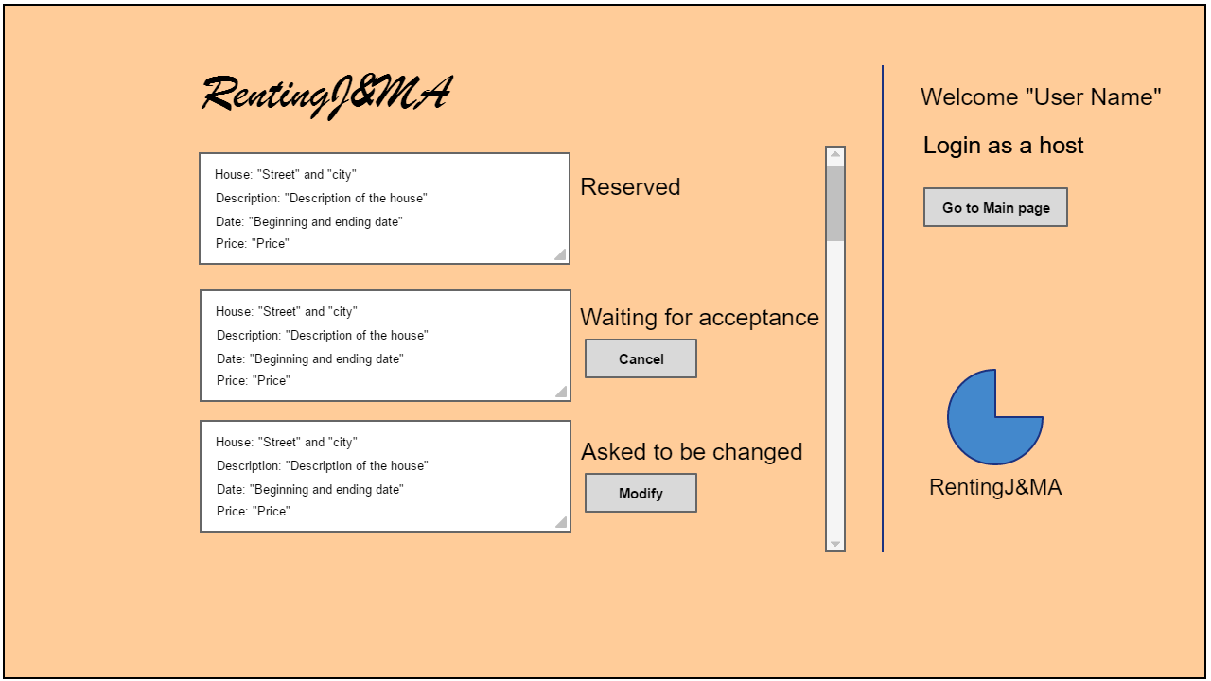

This is a list of the offers that the host has created. He will be able to see their information and cancel the ones that hasn’t been accepted yet or modify those who need to be modified.

Admin:

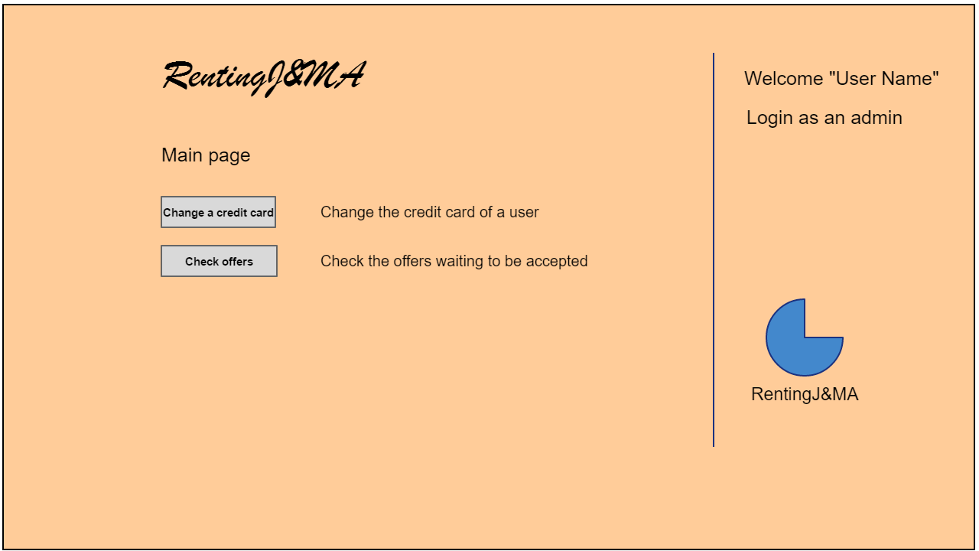

This is the main page of the admin, he can change a credit card or check offers that the hosts create.

This is the screen that appears when he selects “Change a credit card”:

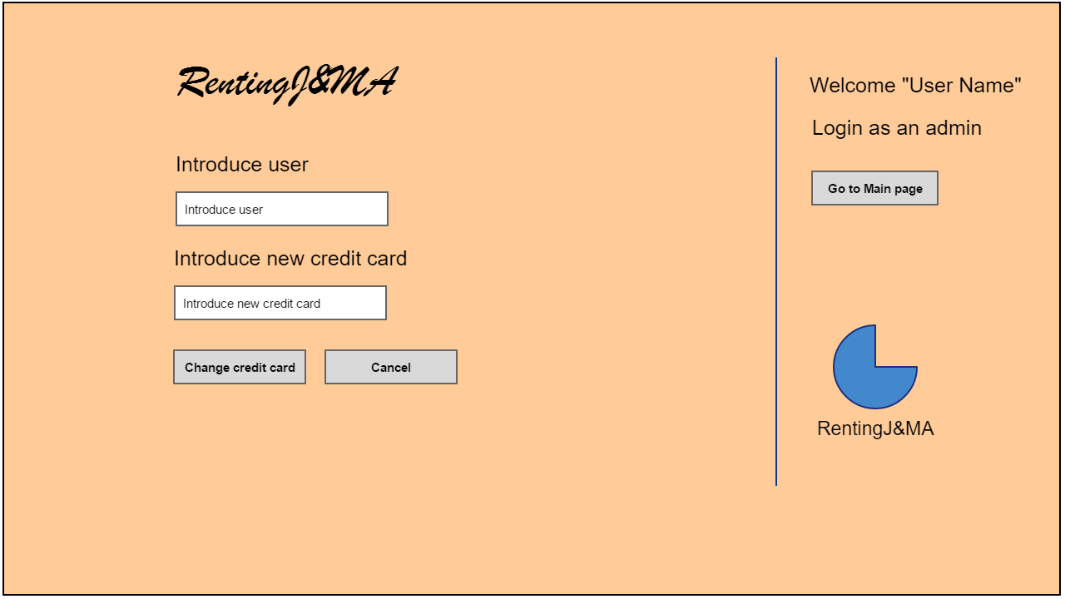

The admin can introduce the name of the user and his new credit card and submit by pressing “Change credit card” or cancel.

If from the main page the admin selects “Check offers” he will see this screen:

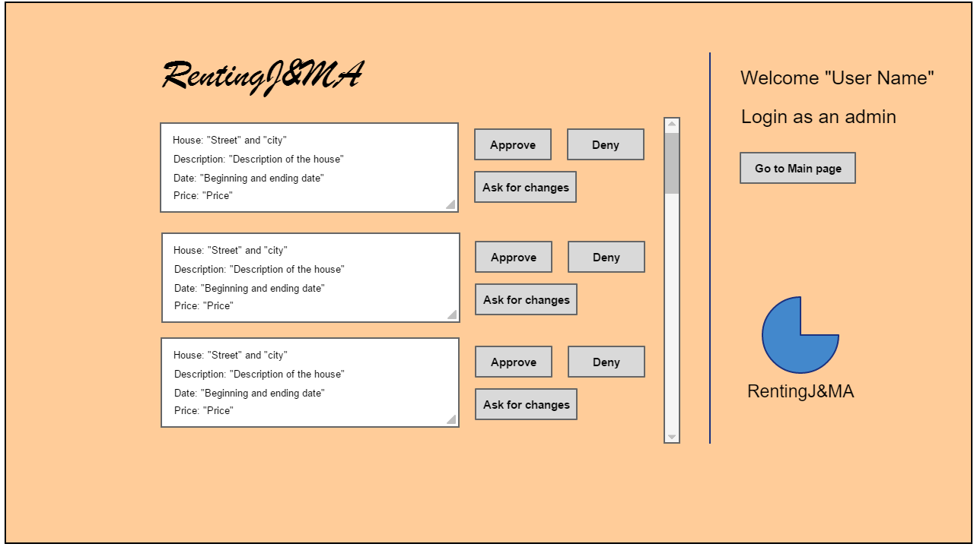

The admin will se all the offers waiting to be accepted and check them as he pleases: he can approve them, deny them or ask for changes.

He will also be able to go back to the main menu by pressing “Go to Main page” as always.